8.0 | Implementation Recommendations

8.1 Preamble
This section of the report considers how the preceding conservation policy can be implemented. The following series of recommendations summarises the actions necessary to be undertaken by NPWS in order to implement the Conservation Policy. Priorities and timing are indicated where there is a level of urgency or timing and co-ordination is an issue. Adequate funding is required to undertake any comprehensive program. The national environmental significance and state level of cultural significance of the Precinct justifies funding.

8.1.1 Precinct Purpose Statement
The purpose of the Yarrangobilly Caves House Precinct is to preserve and conserve the Karst environment and to continue to provide for and encourage the historic tourism use of the precinct for the education, recreation benefit and inspiration of present and future generations.

8.1.2 Management Challenges
The implementation recommendations in this Section of the report address the following challenges in the management of the Yarrangobilly Caves Precinct:
- Meeting NPWS goals including:
- Public access, education and recreation;
- Cost effective operations;
- Maintenance of a public interface.
- Creation and maintenance of a viable and sustainable tourist operation in a remote and sensitive environment.
- Environmental management :
- Weed control;
- Rare and endangered plants and animals;
- Visitor impacts;
- Karst impacts.
- Transport and site circulation issues:
- Access to and from the site;
- Vehicular circulation within the site;
- Parking within the site;
- Vehicular pollution impacts.
- Perceptions of conflicts with local business operations.
- Inadequate and old fashioned existing visitor facilities and accommodation;
- Preservation and conservation of archaeological resources;
- Conflicts between adventure tourism, recreational tourism and natural heritage and cultural heritage conservation needs.

8.2 Strategic Approach
This study has revealed a range of issues associated with the inability of existing infrastructure to cater for site use at the present and into the future or for greatly increased site usage. Future site use requires a sound basis in site management planning, research into new technologies and requires rigorous business and marketing planning.

8.2.1 Three Stage Process
The proposed strategic approach for the future use and development of the site is a three stage process culminating in staged implementation.

Stage 1
Adopt the findings of the Conservation Management Plan in order to preserve the Precinct’s significance values and to minimise impacts to the karst.

Stage 2
Undertake a research and planning phase. Research new technology options for Precinct needs including: sewerage disposal, power, supply, water purification and reticulation, communications equipment and on site visitor circulation and in the longer term undertake scientific studies and surveys. [It is recognised that some research in these areas is underway] Assess and prepare feasibility and business plans, environmental assessments for future development options.

Stage 3
Staged implementation development based on the findings of the research and planning phase.

8.2.2 Precinct Philosophy Statement
The Precinct Philosophy Statement provided in Section 7.2 has arisen as an outcome of this study and supports the vision of the future use of the Precinct but should be reviewed and updated by NPWS over time.

8.3 Stage 1: Adopt the Findings
Area where staff housing and dormitory / cabin style accommodation may be sited subject to guidelines.
New Visitors Center and parking for light vehicle/ mini bus interchange.
New caravan and camping park to be sited within this area subject to archaeological findings.

Two way road
Light vehicles, mini buses and service vehicles only roads
Loop walking track
Option for pedestrian only precinct within this area.

Light vehicle maintenance and storage
Recommendation 1: Adopt the findings of the Conservation Management Plan.

8.4 Stage 2: Research and Planning Phase

8.4.1 Preamble
This phase is intended to identify appropriate new technologies and to provide the planning inputs required for the future management and development of the Precinct. It is recognised that some of this planning is already in train and that during this process work and development of the Precinct cannot stand still. Ongoing works and development are referred to in Section 8.12.

8.4.2 Research and Planning (1-5 years)
This phase has four complementary streams:
- Identify appropriate new technologies that will improve pollution control/ efficiency and effectiveness of systems within the karst area. [See 8.4.3]
- Prepare and assess Environmental Feasibility, Business and Marketing Plans based on the future opportunities identified in this Conservation Management Plan. [See 8.4.4]
- Prepare Precinct Management Plans to address specific aspects of the sensitive environment for example Risk Assessment. [See 8.11]
- Establish Community liaison mechanisms and structures. [See 8.4.5]

8.4.3. Identify New Technologies
The identification of appropriate new technology to minimise potential impacts to the karst and the natural landscape and to improve the efficiency and effectiveness of current systems is identified as an important input to planning the future development of the Precinct. Research into new technologies will involve allocation of staff time and may involve expenses associated with travelling to see sites where the specified technologies are being used.
Recommendation 2 : Year 1; Research should be undertaken into new development options for:
- Sewerage collection and treatment;
- Communications options;
- Power schemes for isolated places;
- Lighting options for cave lighting;
- Options for Show Cave walkways, non-slip handrails and control of visitor pollution introduced into caves;
- Transport and site circulation options.

8.4.4 Prepare and Assess Environmental Feasibility, Business and Marketing Plans
There are many possible options for the future development of the Precinct. However, within the context of NPWS corporate aims, the use of environmental, business and marketing plans is proposed to ensure cost effective and appropriate solutions.
There are a number of areas with potential for future development as business operations identified within the Precinct. However, within this set the Thermal Pool is considered to have low priority. The future businesses can be run by NPWS or in certain cases leasing of business operations to specialist operators may be appropriate.
Recommendation 3.: 1-5 Years; Prepare and assess Environmental Feasibility, Business and Marketing Plans for areas with potential to be developed as future business units:
- Caves House – tourist accommodation and /or hotel and catering services and other potential building future use developments; [See Section 8.5 & 8.6]
- Cave Tours and Site Interpretation; [See Section 8.7]
- Caravan and Camping Ground; [See Section 8.6.5]
- Business opportunities associated with site circulation [for example operating mini-buses and/or golf buggy rental]. [See Section 8.9]

8.4.5 Introduce Community Liaison Mechanisms and Structures

Aboriginal Community and LALC
The management of the Aboriginal Heritage of the area should be carried out in consultation with the Tumut Brungle LALC. The LALC represent a significant stakeholder in this regard. The representation of other Aboriginal groups may also be appropriate. Decisions relating to aspects of the area management including forward planning, public recreation activity, health and safety, land maintenance and infrastructure development could impact upon Aboriginal sites.
Recommendation 4: Plan and introduce structures for formal Aboriginal community liaison and management input. [Within 1-2 Years]

Stakeholders
The local communities have a strong interest in the management and protection of Yarrangobilly Caves House Precinct and in the potential of the operation of the place to contribute to regional tourism. It is appropriate that local and regional tourism bodies and operators, recreational organisations and conservation groups and the local Aboriginal communities are represented in development of marketing and recreational initiatives.
The reference group could be composed of special interest sub groups for example an Aboriginal group, which assisted in the consideration of Aboriginal sites during the forward planning and decision making processes and had direct input into management outcomes. A tourism and recreation group who provide input to marketing and tourism and recreational development planning and a conservation group who could provide input into research and planning for protection of biodiversity and sustainability.
The principal management objective of such a management structure is to preserve and maintain the cultural heritage of the place in accordance with the Summary Statement of Significance and the Conservation Policy.
Recommendation 5: A formal management structure is recommended for input from stakeholders [local and regional tourism bodies and operators, the local community, recreational organisations and conservation groups and the local Aboriginal communities].
Alternatively the input from the stakeholders could be on an as needs arise basis. This could take the form of a consultative committee or reference group/s.

8.5 Future Use Options/ Directions for Caves House

8.5.1 Preamble
Caves House is a building complex with high and ongoing maintenance costs and a major capital works requirements for the two storey wing that is and will be a financial drain on the Service and the Precinct funding unless the complex can be developed to provide some commercial return. In terms of retention and enhancement of heritage significance it is considered important that the buildings are used.
However, the extent of development possible for the Caves House complex must be balanced by the need to preserve historic fabric and site features, and is constrained by financial impacts, the physical limitations of the site and the need to limit potential impacts to the karst.

8.5.2 Adaptive Re-use Options for the Caves House Complex
The Caves House complex is suitable for a range of adaptive re-use options that are of low to moderate impacts of a level considered to be acceptable in heritage terms because they are compatible with the retention of the significance of the place.
In terms of conservation planning minimal intervention to existing historic fabric is preferred to a scenario involving major change and impacts to historic fabric. On the other hand the potential impacts to historic fabric have been minimised by the selected design in all the adaptation option scenarios. See Figures 6.3 to 6.5. In addition the Caves House complex has historically been subject to major change with buildings being altered, relocated and built with great rapidity from the 1880s to around 1940 and continued change is seen as appropriate within the framework of legislation and appropriate planning.
Any decisions regarding alterations and adaptation for future use will be subject to the NPWS approval process required under the EP &A Act and will be subject to the findings of a Heritage Impact Assessment.
Recommendation 6: Consider and assess the following adaptive re-use options [or combinations of options] to determine a preferred future use of the Caves House complex [Within 1-3 Years]:
- No change to the existing historic fabric of the 1901 building except upgrading of the existing bathrooms and existing kitchens and restoration of the two storey wing. [Low/no impact and low economic potential]
- Minimal change to the historic fabric of the two buildings with some rooms sacrificed to make additional bathrooms and the installation of a commercial kitchen and a new laundry. [low impact and reduced available rooms]
- Change to the fabric of the existing buildings to provide ensuite bathrooms to all rooms, the installation of a commercial kitchen and a new laundry. [Moderate impact with reduced rooms]
- The above scenario (3) with a suite of new accommodation and guest facilities rooms in a new building/s located to the south and east of the present building. [Moderate impact with increased accommodation]
- Combinations of the above (2 & 4) involving provision of several different levels of accommodation within the complex.
Provision of several different levels of accommodation within the complex to cater for different existing building layouts and visitor segments at different prices should be given strong consideration.
See Figures 6.3 to 6.5 to identify the works associated with future use options 2, 3, 4 and a concept design example for Option 5.
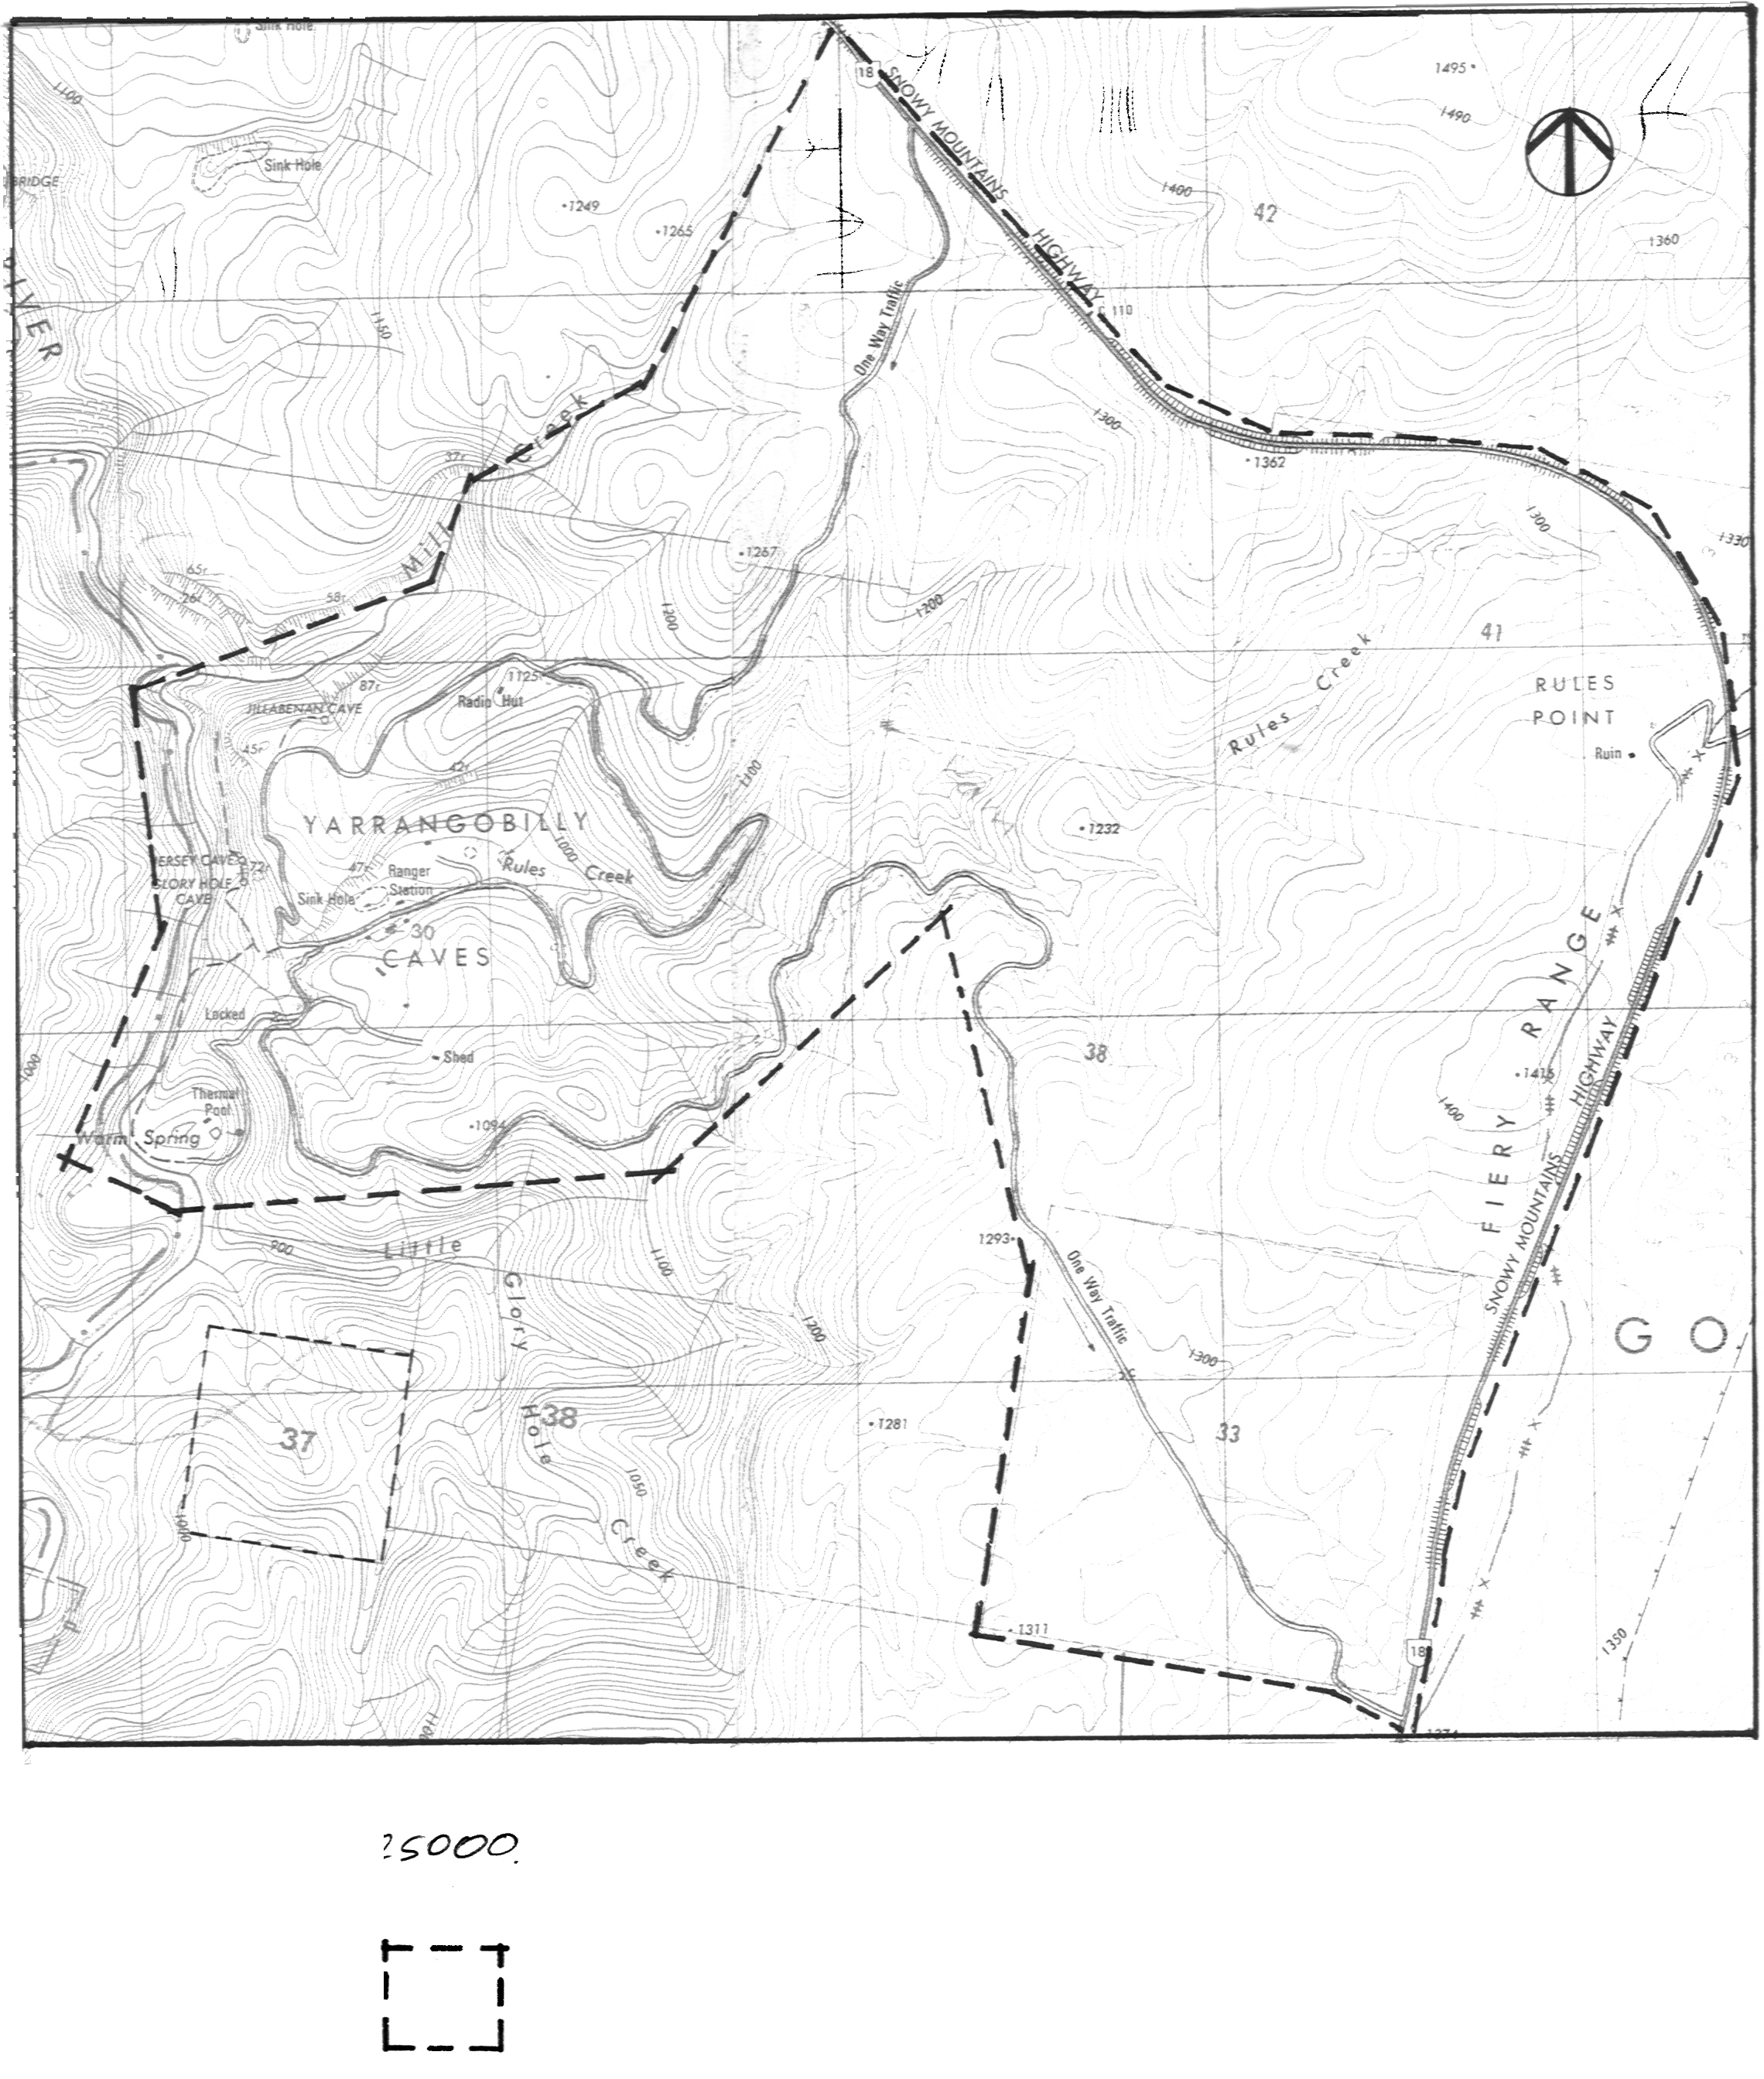
See expanded plan for areas suitable for new buildings in the vicinity of the Caves House complex
Areas with potential for new buildings subject to archaeological survey findings and design guidelines and assessment in accordance with appropriate legislation.
Areas suitable for new buildings subject to design guidelines.
Existing buildings
Figure 8.1 Areas with potential for new buildings.

Figure 8.2 Inset showing areas with potential for new buildings in the vicinity of Caves House and the Visitor Information Centre, subject to archaeological survey findings, design guidelines and assessments in accordance with relevant legislation..

8.5.3 Archaeology Associated with Development in the Vicinity of Caves House
Archaeological deposits associated with both former Aboriginal occupation and former buildings in the vicinity of Caves House are an issue in terms of future development around the existing buildings.

Historical Archaeology
In terms of historical [European] archaeology, it should be recognised that archaeological deposits in the vicinity of Caves House are associated with early twentieth century functional buildings and infrastructure for caretaker and guest accommodation. The site is not likely to be considered to have potential to provide research information that is not readily available elsewhere. The likelihood of an archaeological dig being required prior to excavation is considered to be low.
Recommendation 7: Prior to any excavation works for new buildings, advice should be sought from the NPWS Historical Archaeologist concerning the level of monitoring required during the excavation.

Aboriginal Archaeology
The evidence of former Aboriginal occupation of the area is in the form of an open scatter of artefacts opposite the Visitors Centre around Caves House and its access track on the gently inclined slope. The fact that the scatter is located in an area overlaid by a roadway and occupied by former buildings suggests that some sites are disturbed.
The full length of the former road was not inspected during the course of the present study. Its location and content should be verified prior to new use of the former dirt service road traversing the slope.
The visible open artefact scatter in the lower area is restricted to the dirt road exposure along the access road to the c.1966 cottage. There is low potential for intact subsurface potentially artefact bearing deposit in this location.

Recommendation 8: The saddle between the Caves House and the c.1966 Cottage should be fully recorded prior to any alteration in land use or building in the area or possible increase in traffic along the road.

8.6 Development Control Guidelines

8.6.1 New Buildings/ Structures on the Site

Recommendation 9: New buildings on the site are only appropriate as buildings or additions in the area indicated in Figure 8.2.

Recommendation 10: New buildings or additions within the Precinct will be designed according to the following guidelines.

8.6.2 Guidelines for New Buildings or Additions to the Caves House Complex
- New buildings or additions to must be designed to be sympathetic to the period and style of Caves House and must take into account the way visitors and vehicles will circulate through the site.
- New buildings or additions should be sympathetic modern designs of no more than two storeys along the existing line of buildings and no more than three storeys in the available area behind Caves House.
- The footprint of any new building should respect the layout and features of the existing complex and should not obscure any key views to and from Caves House. (See Figure 6.1 for Key Views)
- Paving of areas for outdoor use (south and east of the Dining Room south west of the Caretakers Cottage) is appropriate providing the installation is designed to be reversible.

8.6.3 Guidelines for a New Visitors Centre
- A new Visitors Centre should where possible be located off the karst and out of the view corridor of the Caves House complex in a location where traffic into the karst area can be monitored and entrance fees collected or ticket sales made. An appropriate location is in the vicinity of the junction of the exit road, the road to the Thermal Pool and the plateau.
- The design of a Visitor Centre is not constrained by heritage requirements if the Visitor Centre is located outside the viewing corridors associated with Caves House. However the structure should be complementary to the style and scale of the buildings within the Precinct.
- A new Visitors Centre should be purpose designed to a high standard of architectural excellence taking into account the spatial needs for ticket sales for caves tours, interpretation media and presentation of displays, retail sales and visitor circulation as well as for storage and archiving.

8.6.4 Guidelines for Other Potential New Building Developments
There is no heritage constraint on additional building on the plateau south of the Caves House complex. However, the location of the sewage treatment and effluent disposal plant in this area would be a constraint on public access to the area, although limited additional staff accommodation may be appropriate.
- Any area developed for Service and or staff accommodation and the existing accommodation buildings [the c.1966 Cottage and the c.1968 rangers Cottage] should be screened from tourist accommodation by suitable plantings and indicated by signage.
- Staff housing should be low key and modern and may be developed with a higher density than other accommodation areas.
- Development should generally be one or two storeys unless there is a sound practical reason for higher structures.
- Development density should be kept low with open space and bushland between buildings.
- Cottage style accommodation may be designed with a conscious reference to the design of the original caretaker’s cottages, but may use modern materials and technology.
- Dormitory accommodation should be low scale and domestic in character using modern materials and technology.

8.6.5 Guidelines for Caravan and Camping Grounds
- Any new camping grounds should be located off the karst and outside the view corridors of the Caves House complex.
- Site access and egress to and from the highway and minimised visual impacts from car and caravan parking and camping equipment, should be considerations in the selection of an appropriate site together with Precinct and cave accessibility and security.
- A location that has been disturbed by previous activities or occupation should be preferred over an undisturbed site, subject to archaeological Research Design [European and Aboriginal] and survey findings.
- Required infrastructure should be low key and modern, and buildings should be single storey unless there is a sound practical reason for a higher structure.
- Technology that minimises impacts to the environment should be utilised where possible.

8.7 Cave Tours
Caves tours could be developed as a module prepared and approved by NPWS and all or part of the operation of cave tours could be leased to a private operator.
Recommendation 11: In the longer term consideration can be given to whether cave tours would be better retained by the Service or offered as a lease. If leasing is the preferred option then a cave tour module should be prepared.

8.8 Site Circulation
Catering for private motor vehicle and coach transport around the site and over the karst has high actual and potential impacts on the Precinct. Impacts are associated with vehicle emissions, visual pollution, wear and tear on the roads, weight and size issues for road sizes and parking lots and turning circles. Much of the karst landscape is also very steep and not suitable for construction of new roadways. There are also issues about risk management in terms of the weight of vehicles travelling over the top of the Glory Hole cavern.

8.8.1 Light, Low Polluting Vehicle Option
On Hamilton Island in the Whitsundays, golf buggies are used almost exclusively for visitor transport because they are small and light, they can carry up to six people [long wheel base buggies carry groups including children of 8 to10]. The buggies can be speed controlled, have low levels of emissions and can cope with very steep conditions. They can also utilise narrow roadways and cope with tight turning situations. They can be provided with plastic zip up covers for weather protection.
Fleet operators who maintain the vehicles let the vehicles on an hourly, half daily, daily, overnight and weekly basis. They add a certain holiday flavour and sense of adventure to the place and the holiday experience. Use of such a vehicle fleet means that private cars could be kept out of the karst area which could be restricted to light vehicle and pedestrian use.
Such vehicles could provide transport to and from the Thermal Pool on the existing roadway if it was paved with tarmac or concrete and a footpath added. They could also travel around the Loop Road to and from the Caves. Golf buggies could be used together with small buses around the Precinct.
It is possible that in addition to golf buggies there are other small, light vehicles options that might suit Yarrangobilly’s special needs.
Recommendation 12: In order to protect the karst and to better manage vehicle impacts it is recommended that alternative light, low polluting vehicle options and transport systems for use by visitors to the Precinct are researched and assessed, including consideration of financial and environmental opportunities and impacts.

8.8.2 Small Buses
Use of small buses within the Precinct would allow guided Cave Tours to start at the Visitors Centre and be controlled by the Guide at all times. This allows members of bus tour groups too large to form a single guided tour group to wait at the Visitors Centre or at Caves House rather than trying to develop facilities near Cave entrances. The Guide buses could operate in conjunction with the light low polluting vehicles that could park in the existing car parks [except the car park near the Self Guiding Cave exit, which should be rehabilitated].
Recommendation 13: Use of small buses [around 12-18 seaters] to accommodate cave tour groups driven by the guides and carrying the tour group from the Visitors Centre to the Caves should also be explored.

8.9 Future Use of the Thermal Pool
The Thermal Pool is generally regarded as a local recreational asset. The pool is also recognised as always having had an essentially primitive, making do in the bush character, which should be retained and conserved in any future development.
Nonetheless within this constraint it would be possible to considerably upgrade the presentation and opportunities associated with the use of the pool.
Recommendation 14: Developments in the vicinity of the pool can be considered The current approach to management of the pool should only be reconsidered if circumstances associated with the pool maintenance or use, change substantially.

8.10 Precinct Management Planning and Interpretation
A number of planning documents should be prepared by appropriately qualified and experienced specialists to assist in the management of the sensitive environment. The planning is arranged in order of priority within a time scale. Required Plans are:
Recommendation 15: In the next 1-2 Years [by 2003] prepare the following Management Plans:
- Complete the Fire Management Plan currently being developed.
- Prepare a Risk Assessment Plan for the Precinct.
- Prepare a Site Circulation/ Traffic Management Plan.
- Prepare a comprehensive Landscape Analysis and Plan for the Precinct that expands on the Interim Landscape Plan. [See 7.8.6 and Appendix K ]
- Pest species management [flora and fauna] should be consistent with the South West Slopes Regional NPWS Plan [See 7.8.4]
Recommendation 16: In the next 2-10 years [2002-2010] Prepare the following:
Prepare an Interpretation Plan for the Precinct, which includes consideration of the cost benefits, financial impacts and design requirements for a new Visitors Centre.
Recommendation 17: Scientific research and bio diversity survey is recognised as necessary to assist in management of communities and species associated with the Yarrangobilly limestone. Suitable projects will be included in a research prospectus for Kosciuszko National Park and circulated to universities and other research institutions.

8.11 Stage 3: Staged Implementation
The following staged implementation plan will be expanded based on the Stage 2, Research and Planning Phase.

8.11.1 Infrastructure Development Works [1-10 years]
The following are task oriented recommendations that may be prioritised according to perceived threats, available funding and community interests.
Recommendation 18: Implement the following Infrastructure development works over the next 1-10 years.
Based on the outcome of research into appropriate new technologies:
- Upgrade/ improve communications
- Replace the existing Sewerage System with a system using new technology and capable of servicing peak numbers of visitors.
- Install a water purification system to purify water for use in the Precinct.
- Install power generating equipment to supplement the existing and meet potential peak demands.
- Replace existing lighting in:
- North Glory
- Self Guided [South Glory]
- Jillabenan Caves
- Replace handrails and walkways within the Show Caves that are considered a risk for visitors.
- 7. Investigate reinstatement of the Natural Bridge Walking Track.

8.11.2 Caves House Complex
Recommendation 19: Based on options in Recommendation 3. And 6. make decisions regarding the future of Caves House and carry out appropriate works to the Caves House Complex.

8.11.3 Visitor Centre
Recommendation 20: Investigate the design and construction of a new Visitor Centre in accordance with the Guidelines in 8.6.3. [Design 1-2 years by 2003, Construct by 2005]
Re-use and adapt the existing Visitors Centre for a compatible new use: Café, staff accommodation or visitor accommodation. [When the New Visitors Centre is completed]
Consider site circulation and car parking when selecting a site for a new Visitor’s Centre.

8.11.4 Site Circulation Works
Recommendation 21: Investigate Precinct circulation trails and works in the specified timeframes:
- Trial use of one or several selected low polluting, lightweight vehicle/s for use around the site and select a preferred vehicle [within 1- 2 years by 2003]
- Liaise with the RTA to widen the exit road to make it a two-way road at least as far as the Leo Hoad Gateway. [Within the next 2- 3 years by 2003]
Recommendation 22: Develop a site circulation plan taking into consideration vehicle emissions, road maintenance, parking and turning, weight and size issues and potential for visual pollution and impacts on the karst.

8.11.5 Thermal Pool

General
Essentially little or no major change is required in the short term.
Recommendation 23: Carry out the following works to the Thermal Pool area in the time frames specified:
- Investigate the need for a safety pool fence and consider planting bush raspberries around the fenceline. [Within one year by 2002]
- Investigate options for access to the Thermal Pool in accordance with 8.11.4. [By 2003]

Aboriginal Archaeology
Existing infrastructure has caused disturbance to open sites in the area of the Thermal Pool and at the beginning of the River Walk. The relocation of these facilities or re-routing of the walk is not recommended, as this would add to the existing disturbance.
Recommendation 24: A stable surface [such as sterile topsoil or gravel] should be installed over areas of known distribution of artefacts on the River Walk or the artefacts should removed to a safe location in consultation with the LALC.

8.11.6 Glory Hole Farm

General
Recommendation 25: Investigate the development and construction of a loop track incorporating the present track and the Glory Hole Farm site. [Within 5 years by 2005]

Aboriginal Archaeology
Recommendation 26: Stone artefact scatters have been recorded along the track to the farm, at the farm and at the Harris family cemetery. Immediate protection and stabilisation measures are required on the steeper slopes where artefacts are located to minimise slope wash and displacement of artefacts. This could involve the installation of sterile gravel deposits over existing tracks, which would also help to formalize visitor movement through the area. Alternatively the artefacts could be relocated to a safe location in consultation with the LALC.

8.12 Ongoing Site Management and Maintenance

8.12.1 Existing Site and Building Fabric Management
The following table (Table 8.1) sets out the significance values and the associated management actions appropriate to the level of significance of fabric and relates to table 5.1
Table 8.1 Significance Management
Significance Value | Management Approach
5 Very High Significance | Retention and conservation essential; stabilise, preserve, reconstruct and restore.
4 High Significance | Retain and conserve if possible, reconstruct based on known evidence.
3 Some Significance | Retention and conservation desirable but not essential, suitable for adaptive re-use
2 Low Significance | Modern fabric, or fabric of low significance and/or integrity, which may be altered or replaced as desired
1- 0 No significance | No heritage significance value. If identified as a detracting element (0) those items should be removed.

Recommendation 27: Manage items and fabric within the precinct according to the significance management approach outlined in Table 8.1.

8.12.2 Cyclical Maintenance for Buildings
The Minimum maintenance standards [See 7.1.3 and guidelines supplied by DUAP] required by the NSW Heritage Office Heritage Amendment Regulation 1999 should be adhered to.
Recommendation 28: Cyclical maintenance of buildings within the Precinct should be carried out according to the following guidelines.
Guidelines for Cyclical Maintenance within the Yarrangobilly Caves Precinct
- Buildings are to be thoroughly inspected at least once a year (as a minimum) for evidence of deterioration of exterior or interior surfaces for example deterioration of corrugated iron and exterior timbers and they should be made good as required. This will include an inspection of electrical equipment and an annual termite inspection by a licensed operator.
- Painted surfaces should be examined on an annual basis and a decision about potential weathering of surfaces should guide the decision to repaint. Surfaces that are currently painted should be repainted in matching colours and paint types where painting will preserve or extend the life of building materials.
- Water run-off in the vicinity of the walls of the buildings should be monitored on an ongoing basis and the drains and the sewage system should be kept cleared and operational.
- Grass cover and tree growth in the vicinity of Caves House should be managed and maintained as a lawn so that it does not become a fire hazard.
- NPWS to install/ maintain fire prevention and fire fighting equipment to meet relevant standards.
- The adjacent grounds and the Picnic Grounds will be maintained in substantially their current form, with gardens maintained, lawns mowed regularly, trees and shrubs monitored and replaced as required and trimmed to preserve key views.

8.12.3 Maintenance of Key View Lines
Recommendation 29: Key view lines should be actively managed according to the following guidelines and unsympathetic views should be screened with native vegetation.
- Key viewing lines as indicated in Figure 6.1, should be actively managed to preserve key views.
- This will involve annual inspection and maintenance works to the vantage points including any required upkeep to tracks and safety fences.
- As a minimum the view line should be inspected once a year and as required managing of new growth, clearing and trimming of tree and shrub growth along the view line/s should take place.
- Unsympathetic views, for example to the c.1966 Cottage on the plateau south of Caves House should be screened by strategic planting of copses of locally indigenous tree and tall shrub species.

8.12.4 Cyclical Maintenance for Actively Managed Grounds and Tracks
Recommendation 30: Managed grounds and tracks should be managed according to the following guidelines:
- Continue current mowing regime and garbage collection practices.
- Inspect dry stone retaining walls annually to identify failures and repair as required.
- Inspect walking tracks annually and repair bridges, surfaces, railings and fences as required.
- Inspect roads twice a year and repair and maintain as necessary.

8.12.5 Cyclical Maintenance for Show Caves
Recommendation 31: Cyclical maintenance of the Show Caves should be carried out according to the following guidelines:
- Monitor Lampenflora growth and take control measures as necessary.
- During an annual inspection identify areas that have safety issues for visitors/staff and establish priorities for repair/replacement.
- Clean caves as necessary to remove mud, soil, dust, lint and hair from formations and pathways.

8.13 Management of Aboriginal Heritage
[Site specific policies are included in 7.16 for specific places]

8.13.1 General Requirements
Recommendation 32: Proposed works in or near areas of potential Aboriginal archaeological sensitivity based on the existing evidence shown in Figure 3.2 and 3.3. should be preceded by a systematic archaeological survey and area impact assessment.

8.13.2 Burial Repatriation
Recommendation 33: The view of the Aboriginal community should be sought as to the possibility of the repatriation and re-burial on site of the skeletal material removed from the Glory Cave. A suitable site for this and ongoing management of the immediate area should be undertaken in consultation and with the assistance of the Aboriginal community.

8.13.3 Interpretation of Aboriginal Heritage
Recommendation 34: Investigate an interpretation program for the Aboriginal heritage of the Precinct in consultation with the Aboriginal community.
The Aboriginal community should be consulted and their guidance and preferences sought for the infrastructure and signage.

8.14 European Archaeology
The archaeological resource associated with the Caves House complex and caretakers residences is considered to have some value for giving insights into the development of the site itself and into the lifestyle and material possessions of its occupants.
The areas of the site considered likely to be archaeologically sensitive are indicated in Figure 8.4 with the accompanying management recommendations for each unit.
Recommendation 35: European archaeology will be managed according to its level of sensitivity based on the management recommendations in Table 8.2.

Table 8.2 European Archaeological Management Recommendations (See Figure 8.3 for the accompanying Archaeological Sensitivity Plan).
Zone | Sensitivity | Management recommendation
Unit I | Standing Historic Structures and infrastructure buildings. | Retain and conserve no disturbance or excavation without NPWS approval in writing and REF Approval.
Unit II | Areas with high potential to contain undisturbed archaeological deposits related to European occupation. | No excavation or disturbance of sub-surface spaces prior to consultation with, and written approval from the NPWS Historical Archaeologist. For areas related to early occupation, completion of an Archaeological Research Design may be required.  Retain deposits in this zone unless removal is required to actively conserve built fabric of high significance.
Unit III | Areas where archaeological deposits have been disturbed | Generally no restrictions on excavation in these areas. However if deeper excavation than previously carried out (into undisturbed stratified deposits) is proposed, then the NPWS Historical Archaeologist should be notified.
Unit IV | Areas with low potential to retain archaeological deposits | No restriction on excavation in these areas. However, if relics are uncovered then work should cease and the NPWS Historical Archaeologist should be notified.
Unit II
See expanded plans showing details of this area
Unit I
Unit II
Unit III
Unit IV

Figure 8.3 European Archaeological sensitivity plan [See Table 8.2 for accompanying management recommendations].

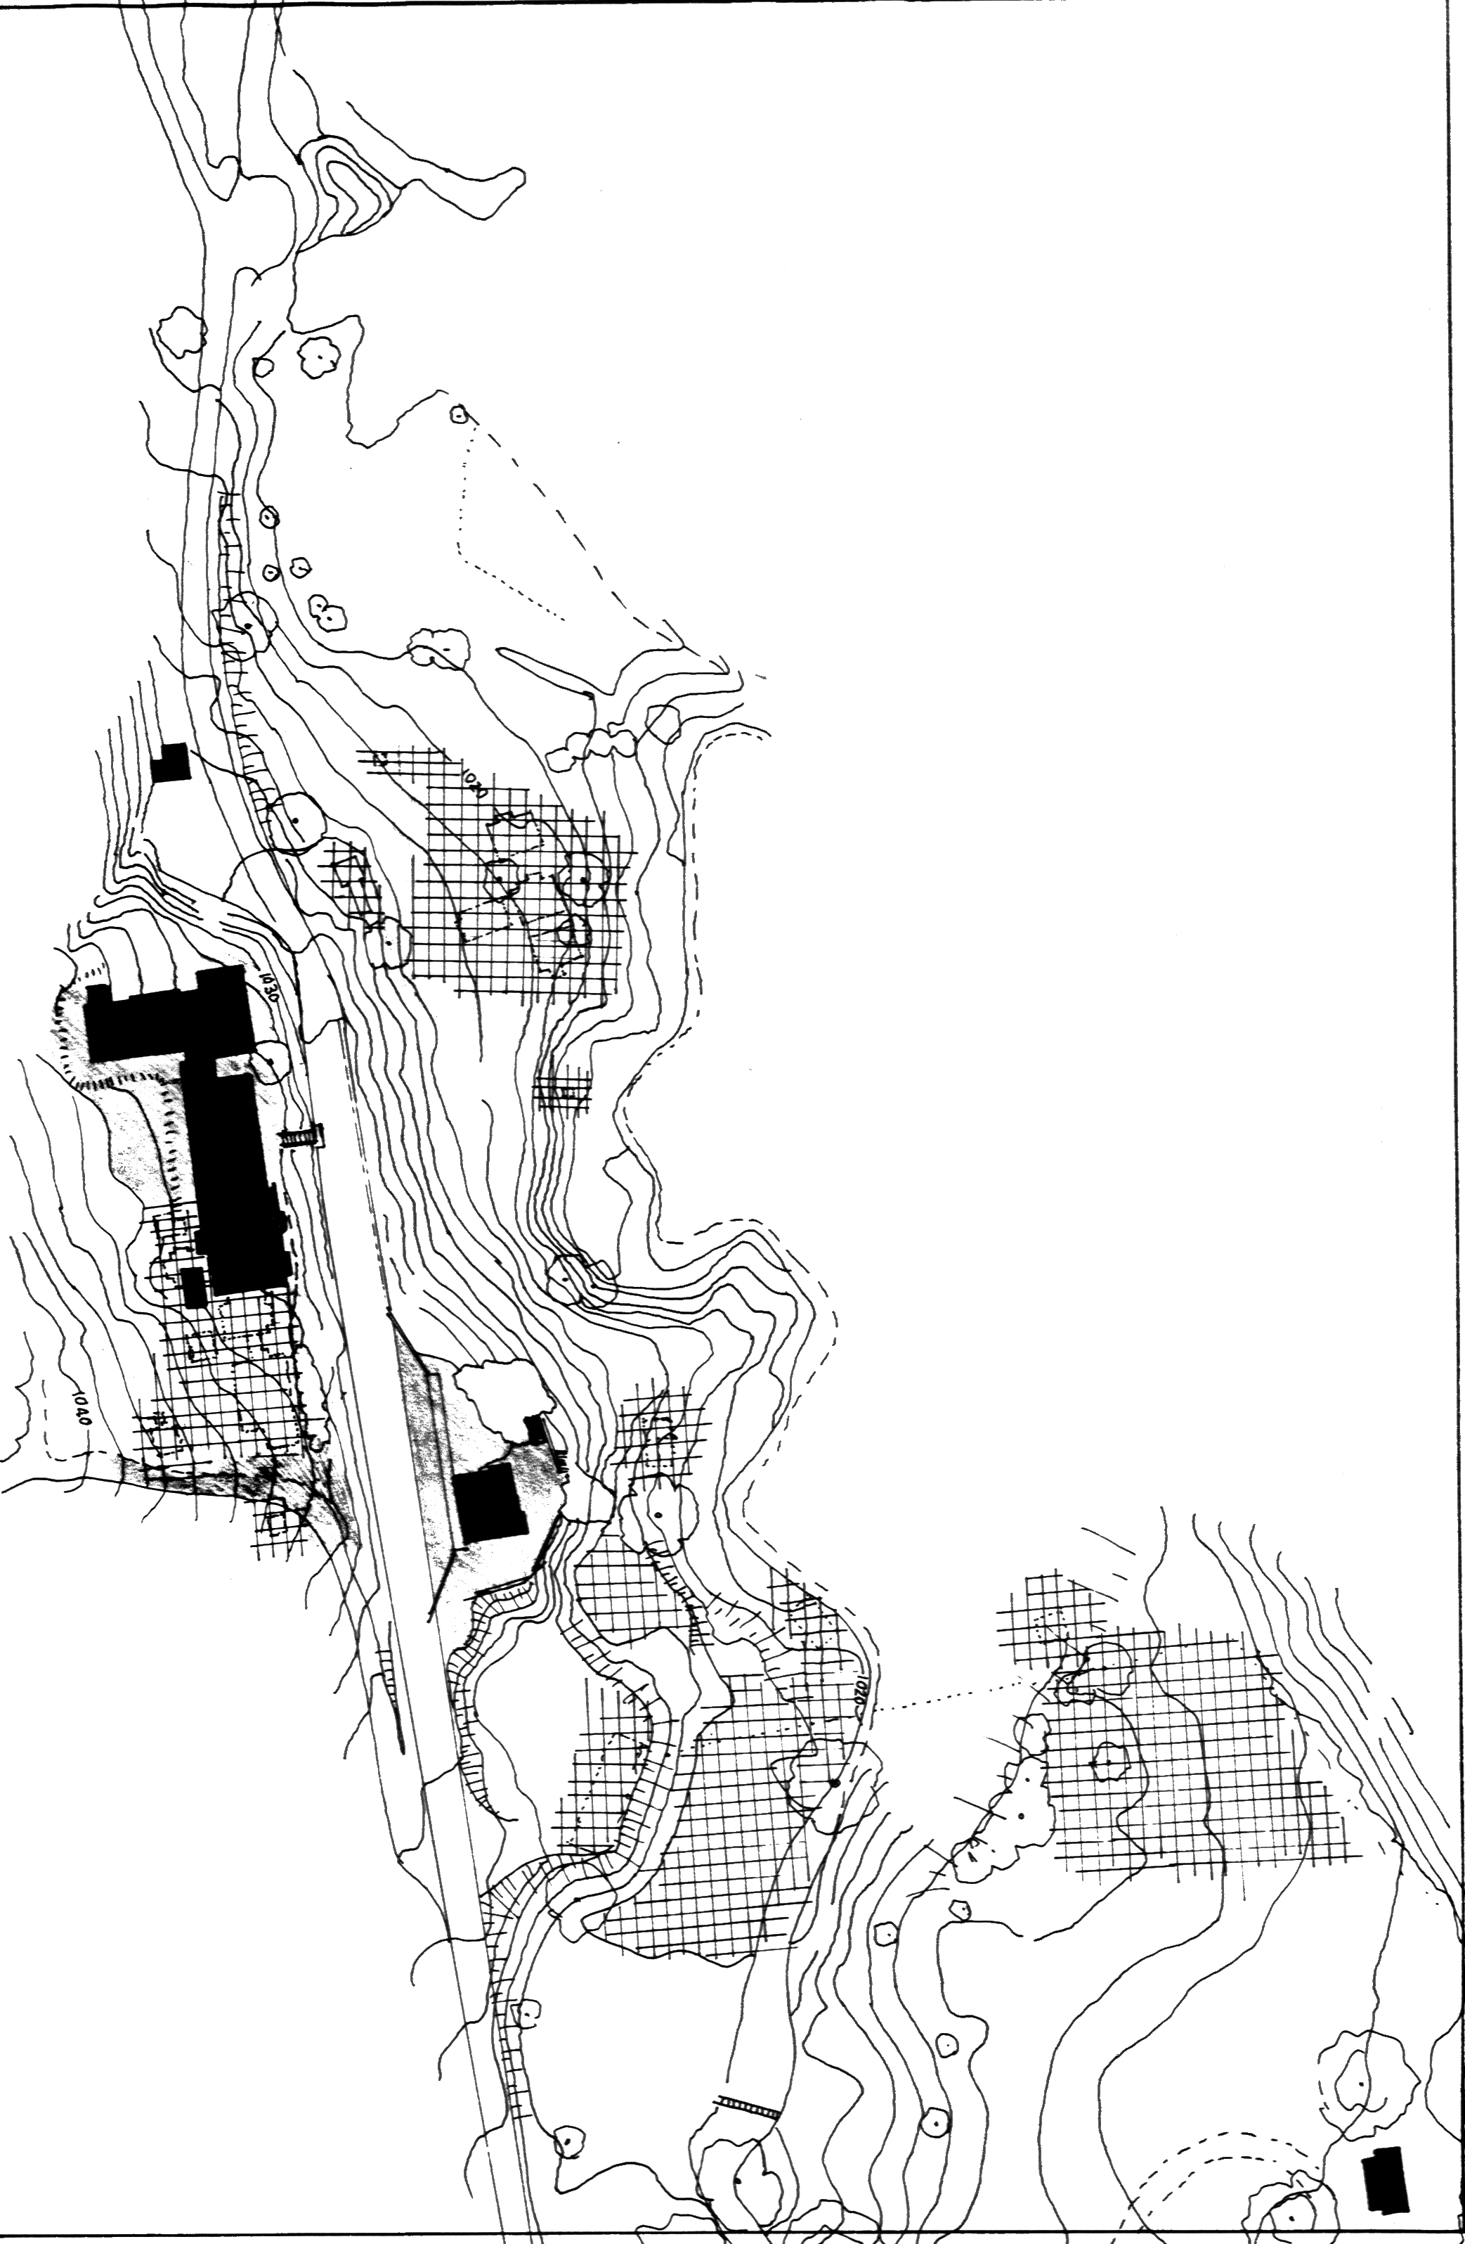
Figure 8.4 European Archaeological sensitivity in the western end of the Rules Creek basin.

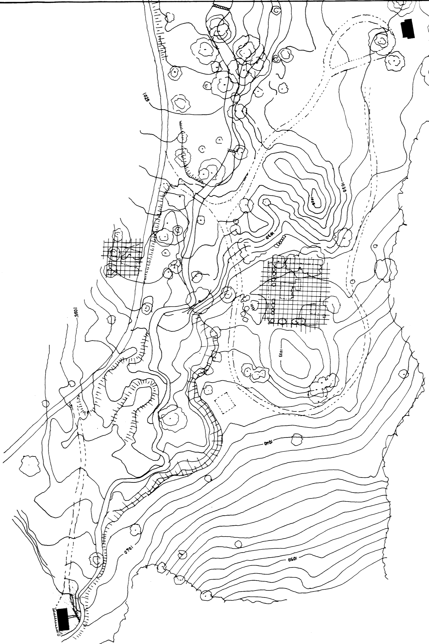
Figure 8.5 Archaeological sensitivity for the eastern end of the Rues Creek Basin.

8.15 Review
Recommendation 36: This Conservation Management Plan should be reviewed at five yearly intervals or with change of leaseholders or major alterations to the site.

Current hiring rates on Hamilton Island [May, 2000] are: 1 hr $15, 2hr $25, 3 hr $30, all day (8.30am to 4.30pm) $40, overnight 5pm to 8.30 am $25, 24 hours $55, 1 week $330.

